Chapter 1: Abstract
This research investigates the effect of varying levels of normal and Nano Urea foliar spray on the growth and yield of Fodder Maize (Zea mays). Fodder Maize is a critical component of livestock feed, and Nitrogen (N) is a crucial nutrient for its growth and development. The scarcity of green fodder in India has led to significant deficits in livestock nutrition, reducing productivity below potential compared to many developed nations.

The experiment was conducted using a Randomized Complete Block Design (RCBD) with seven treatments (T1 to T7), replicated thrice at UASB GKVK Agronomy field unit, E-4 block, ZARS during 2024-25. The study was carried out in a semi-arid region with sandy loamy soil (pH 6.46). Growth parameters including plant height, number of leaves, and leaf area were recorded at 30, 45, and 60 Days After Sowing (DAS). Yield attributes including fresh biomass yield and dry weight of biomass were also measured.

Results indicate that Nitrogen application significantly influenced plant growth and yield. Plants treated with 100% RDF + Normal and Nano Urea foliar spray (Treatment T7 — applied at both 25 DAS and 40 DAS) showed the highest growth and yield attributes compared to all other treatments, with a fresh biomass yield of 5.4 kg/plot — a 74% improvement over the conventional control (T1: 3.1 kg/plot).

Problem Statement
Our Karnataka state hosts approximately 28.6 million heads of livestock with only 3.5% of cultivated area under fodder crops. The annual fodder requirement of the state is 122 million tons of green fodder and 25.4 MT of dry fodder, with a 30% and 45% deficit respectively[ICAR]. Conventional urea application suffers from nitrogen losses due to leaching, volatilization, and denitrification. Nano Urea presents a promising alternative due to its higher surface area, controlled release properties, and improved nitrogen use efficiency. The optimal combination and timing of Normal and Nano Urea foliar spray for Fodder Maize production under Karnataka conditions had not been systematically studied — constituting the core problem this research addresses.

Chapter 2: Introduction
Forages are the backbone of the livestock industry. The mainstay of animal wealth and their production depend on the availability of fodder. The scarcity of green forages and growing resources in the country has made livestock suffer continuously with malnutrition, resulting in production potentiality at sub-optimum levels compared to many developed nations. Livestock breeds with higher milk yielding potential suffer from a deficit in green and dry fodder availability. To overcome this deficit, dairy farmers resort to increased use of costly concentrate foods, which increases cost of production.

As far as Karnataka state is concerned, it is a home for 28.6 million heads of livestock with only 3.5% of cultivated area under fodder crops. Maize (Zea mays) is the 3rd most widely cultivated crop after wheat, grown on an average of 180.64 Mha worldwide. Green fodder maize is one of the most nutritious non-legume green fodders — quick growing, yields high biomass, is highly palatable, and contains enough protein and minerals.

2.1 Methodologies Used
- Randomized Complete Block Design (RCBD) with 7 treatments × 3 replications
- Foliar application of Normal Urea and Nano Urea at different concentration levels (2%) and timings (25 & 40 DAS)
- Growth parameter recording at 30, 45, and 60 DAS (plant height, leaf count, leaf area)
- Yield measurement at harvest: fresh biomass and dry weight
- Statistical analysis via Fischer's ANOVA with CD @ 5% & 1%
- Economic analysis: Gross Returns, Net Returns, and Benefit-Cost Ratio (BCR)

2.2 Results Compared with Existing System
The conventional nitrogen management system (T1: 100% RDF basal application) served as the control. Compared to this baseline, Treatment T7 (100% RDF + Normal and Nano Urea foliar spray @ 2% at 25 DAS and 40 DAS) recorded significantly higher plant height (46.80 cm vs. 41.53 cm at 30 DAS), higher number of leaves per plant (7.26 vs. 6.20), and greater fresh biomass yield (5.4 kg total vs. 3.1 kg). This represents a yield improvement of approximately 74% over the conventional system, validating the superiority of combined Normal and Nano Urea foliar spray [Singh et al., 2019; Amjad et al., 2021].

2.3 Experiment Conducted
The field experiment was conducted at UASB GKVK Agronomy field unit, E-4 block, ZARS during Kharif season 2024-25. The African Tall variety of Fodder Maize was sown on 16/09/2024 with a spacing of 30 × 10 cm and a seed rate of 20 kg/ha. Seven treatment combinations involving varying levels of RDF, Normal Urea, and Nano Urea foliar spray were evaluated in RCBD with three replications. Harvesting was done on 17/11/2024 at the dough stage (65-70 DAS) using a sickle with cutting at base near soil surface.

Chapter 3: Review of Literature
Fodder maize is an important feed crop for livestock and plays a significant role in the livestock industry. Nano Urea is a primary macronutrient required for plant growth and is often a limiting factor for crop production. Thus, the enhancement of growth and yield of fodder maize through different levels of normal and nano urea has been a topic of interest for researchers worldwide.

3.1 Effect of Normal Urea on Fodder Maize
Singh et al. (2019) investigated the effects of different levels of normal and nano urea on growth and yield of fodder maize. The application of 200 kg N/ha resulted in higher plant height, leaf area, and yield compared to 100 kg N/ha [1]. Zaman et al. (2019) found that 300 kg/ha of normal urea produced higher plant height, leaf area, and yield compared to 100 kg/ha application [2]. Singh et al. (2012) studied productivity, economics and quality of fodder maize under varying nitrogen and phosphorous levels, establishing that 150 kg N/ha was the economically optimal dose [4].

3.2 Effect of Nano Urea on Growth and Yield
Singh et al. (2018) showed that 250 kg/ha of nano urea resulted in higher yield compared to 350 kg/ha of normal urea, establishing superior efficiency of nano form [1]. Abdel-Salam (2020) found the highest yield at 180 kg/ha Nano Urea level, with excessive application (>240 kg/ha) reducing yields due to lodging. Amjad et al. (2021) found optimum yield at 150 kg N/ha Nano Urea with highest net return — this level was recommended as optimal for maize growth [5].

3.3 Comparative Studies
Tariq et al. (2019) found 150 kg N/ha of nano urea yielded higher fodder weight than 200 kg/ha of normal urea, also producing higher crude protein content in maize fodder. Al-Tawaha and Abu-Irmaileh (2013) showed that nano urea levels beyond 150 kg/ha did not significantly improve yield. Hussein et al. (2019) confirmed that 250 kg N/ha showed no significant increase over 150 kg/ha, establishing the existence of an optimal nitrogen threshold.

3.4 Nano Fertilizers and Sustainable Agriculture
Naderi and Shahraki (2013) reviewed nano fertilizers and their roles in sustainable agriculture, establishing that particle sizes in the range of 1-100 nm possess unique physicochemical properties enhancing nutrient absorption [2]. Yogendra et al. (2020) confirmed economic viability of nano fertilizers across important winter season crops under Indian conditions [8]. Ajithkumar et al. (2021) found that IFFCO Nano Urea improved maize growth, grain yield, and simultaneously reduced incidence of turcicum leaf blight disease [5].

Overall, literature suggests that combined application of Normal and Nano Urea — particularly through foliar spray at critical growth stages — consistently outperforms conventional basal application alone, with optimal Nano Urea levels varying by variety, soil type, and agro-climatic conditions.

Chapter 4: Objectives of the Research
The objectives of this research are framed using Bloom's Taxonomy action verbs to ensure measurable and meaningful academic outcomes:

- Construct a comprehensive experimental dataset of growth and yield parameters of Fodder Maize (Zea mays) across seven treatment combinations of Normal and Nano Urea foliar spray, documenting various growth parameters at 30, 45 and 60 DAS.
- Evaluate the effect of different levels of Normal and Nano Urea foliar spray on the growth parameters and yield attributes of Fodder Maize under semi-arid field conditions during Kharif 2024-25.
- Compute the economic viability of Normal and Nano Urea foliar spray in Fodder Maize cultivation through Benefit-Cost ratio analysis, comparing gross returns, net returns, and cost of cultivation across all seven treatment combinations to determine the most economically optimal nitrogen management strategy.

Chapter 5: Materials and Methods
This chapter presents the details of the materials used and methodology followed during the investigation at UASB GKVK Agronomy field unit, E-4 block, ZARS during Kharif 2024-25.

5.1 Location of the Experimental Site
The experiment was conducted at UASB GKVK Agronomy field unit, E-4 block ZARS during 2024-25 at mean sea level of 724m, geographically located at 13°5' N latitude and 77°34' E longitude. GKVK is situated at latitude 12°58' N and longitude 77°35' East at an altitude of 930m above MSL. The topography of the experimental site was uniform with a gentle slope towards the western side.

5.2 Physio-Chemical Properties of Experimental Site
The soil has been traditionally classified as red sandy clay loam texture and taxonomically as Alfisok, Vijaypur series, Isohyperthermic family of Oxithalplecertay. This type of soil is suitable to grow fodder maize in any season, with good water holding capacity.

5.3 Experimental Design & Treatment Details

Parameter | Details
Crop | Fodder Maize (Zea mays)
Variety | African Tall
Season | Kharif 2024-25
Spacing | 30 × 10 cm
Seed Rate | 20 kg/ha
Design | RCBD
Gross Plot Size | 1m × 1m
No. of Treatments | 7
No. of Replications | 3
Sowing Date | 16/09/2024
Harvest Date | 17/11/2024

Treatment | Description | NPK (g/m²)
T₁ (Control) | 100% RDF | 32.6: 46.8: 12.5
T₂ | 50% RDN + Normal Urea spray @ 2%, 40 DAS | 16.3: 46.8: 12.5
T₃ | 50% RDN + Nano Urea spray @ 2%, 40 DAS | 16.3: 46.8: 12.5
T₄ | 75% RDN + Normal Urea spray @ 2%, 40 DAS | 24.4: 46.8: 12.5
T₅ | 75% RDN + Nano Urea spray @ 2%, 40 DAS | 24.4: 46.8: 12.5
T₆ | 100% RDF + Normal & Nano Urea spray @ 2%, 40 DAS | 39.6: 46.8: 12.5
T₇ (Best) | 100% RDF + Normal & Nano Urea spray @ 2%, 25 & 40 DAS | 32.6: 46.8: 12.5

5.4 Cultural Operations
- Land preparation: disc plough, cultivator(twice), harrowed and levelled — 14/09/2024
- Sowing: hand dibbled at 5 cm depth in dry condition — 16/09/2024
- Nutrient Management: RDF = 150:75:40 NPK kg/ha; nitrogen applied as Urea and Nano Urea in split doses
- Weed management: hand weeding at 25-30 DAS; harrow for weed removal
- Plant protection: Fall Army Worm — Emamectin benzoate 55G @ 200 g/ha; Downy Mildew — urea application
- Harvest: sickle cutting at base near soil surface at dough stage — 17/11/2024

5.5 Statistical Analysis
The experimental data collected on growth and yield components of fodder maize was subjected to Fischer's method of analysis of variance (ANOVA) wherever F-test was significant. Comparison among treatment means was done on appropriate CD value worked out. Otherwise against CD value, Non-Significant was indicated.

Chapter 6: System Architecture
This chapter presents the system architecture of the experimental study through actual diagrams illustrating the research workflow, process flow, data model, and stakeholder interactions.

6.1 Block Diagram — Experimental Workflow
The block diagram below illustrates the complete system architecture of the experiment — from inputs (soil, seed, fertilizers) through RCBD treatment application, data collection at multiple growth stages, statistical and economic analysis, to the final output recommendation.

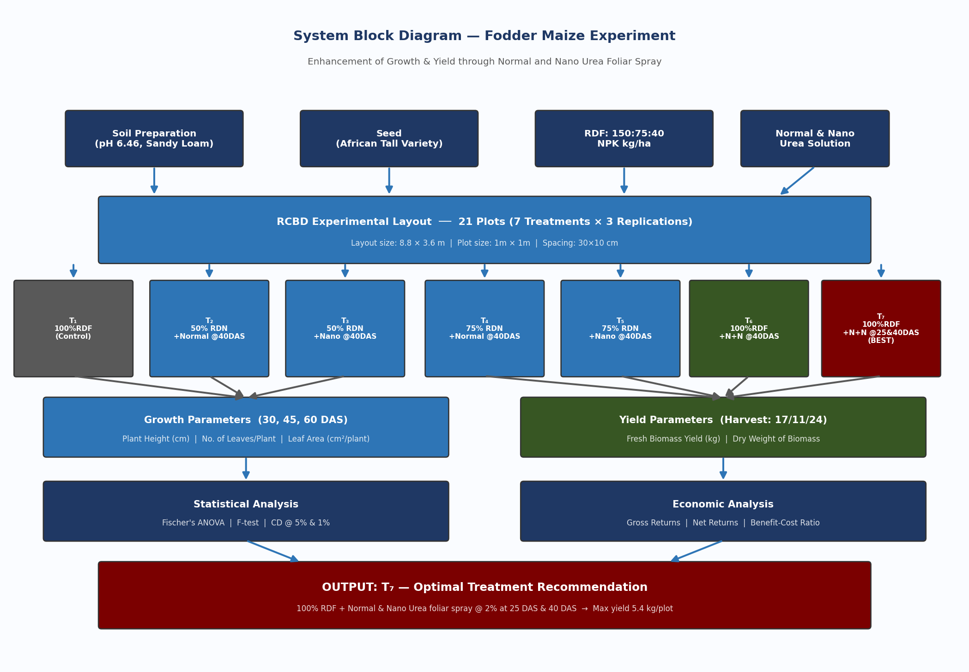
Figure 6.1 — System Block Diagram: End-to-End Experimental Workflow for Fodder Maize Research

6.2 Flowchart — Research Process
The flowchart below captures every decision point and activity in the research process — from site selection and soil analysis, through RCBD layout formation, sowing, basal fertilizer application, foliar spray events at 25 DAS and 40 DAS, data collection at 30/45/60 DAS, harvest, and final statistical analysis.

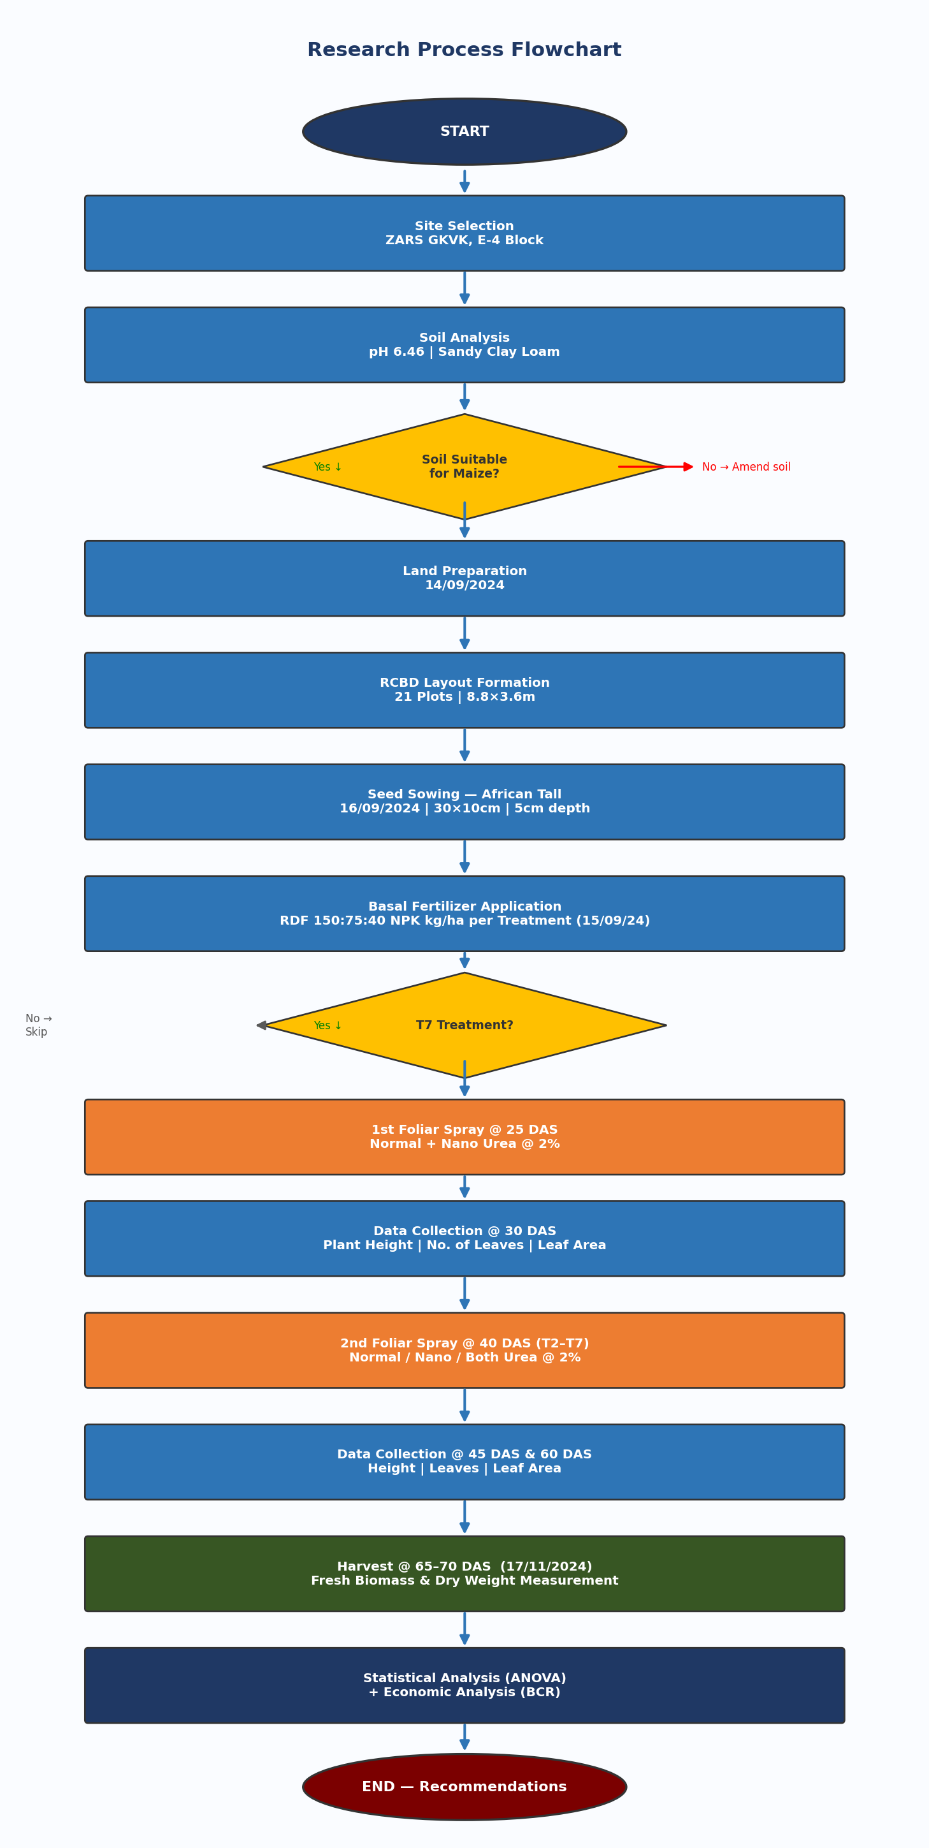
Figure 6.2 — Research Process Flowchart: Sequential Steps from Experiment Design to Recommendations

6.3 Class Diagram — Research Data Model
The UML Class Diagram below models the data structure of the experiment. It shows the key classes (Experiment, Treatment, Plot, Growth Data, Yield Data, Stat Analysis, and Economic Analysis), their attributes, methods, and inter-class relationships — illustrating how data flows from field observation to final BCR calculation.

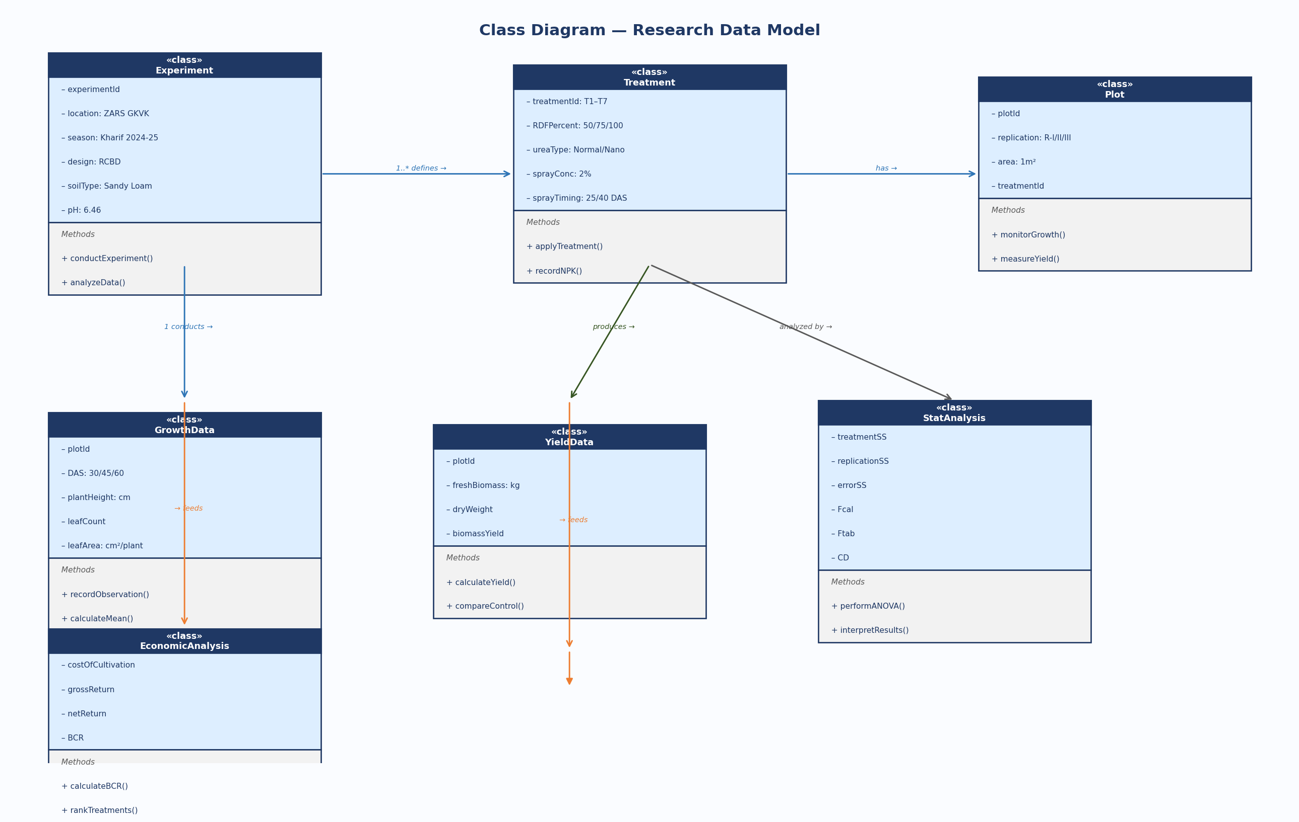
Figure 6.3 — UML Class Diagram: Research Data Model and Class Relationships

6.4 UML Activity Diagram
The UML Activity Diagram uses swim-lanes to depict concurrent activities across three actors — Researcher (blue lane), Field Worker (green lane), and Course Teacher/Supervisor (orange lane). It shows the parallel flow of activities from experiment planning through data collection, spray events, harvest, and final report generation.

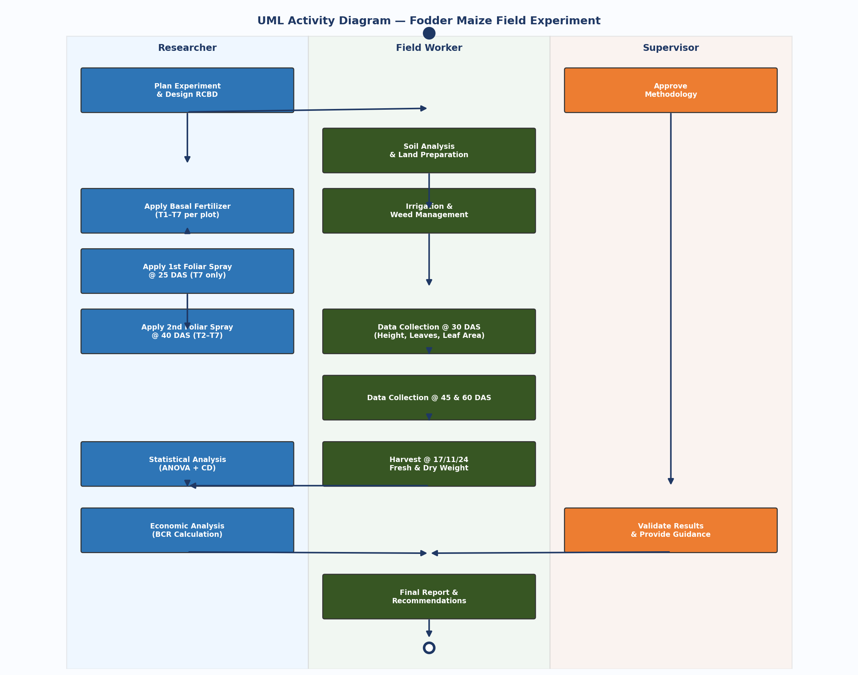
Figure 6.4 — UML Activity Diagram: Swim-Lane View of Concurrent Activities Across Stakeholders

6.5 UML Use Case Diagram
The Use Case Diagram identifies four actors (Researcher, Field Worker, Course Teacher/Supervisor, and Farmer/Beneficiary) and their interactions with the system's use cases inside the system boundary. Dashed lines indicate «include» and «extend» relationships between use cases.

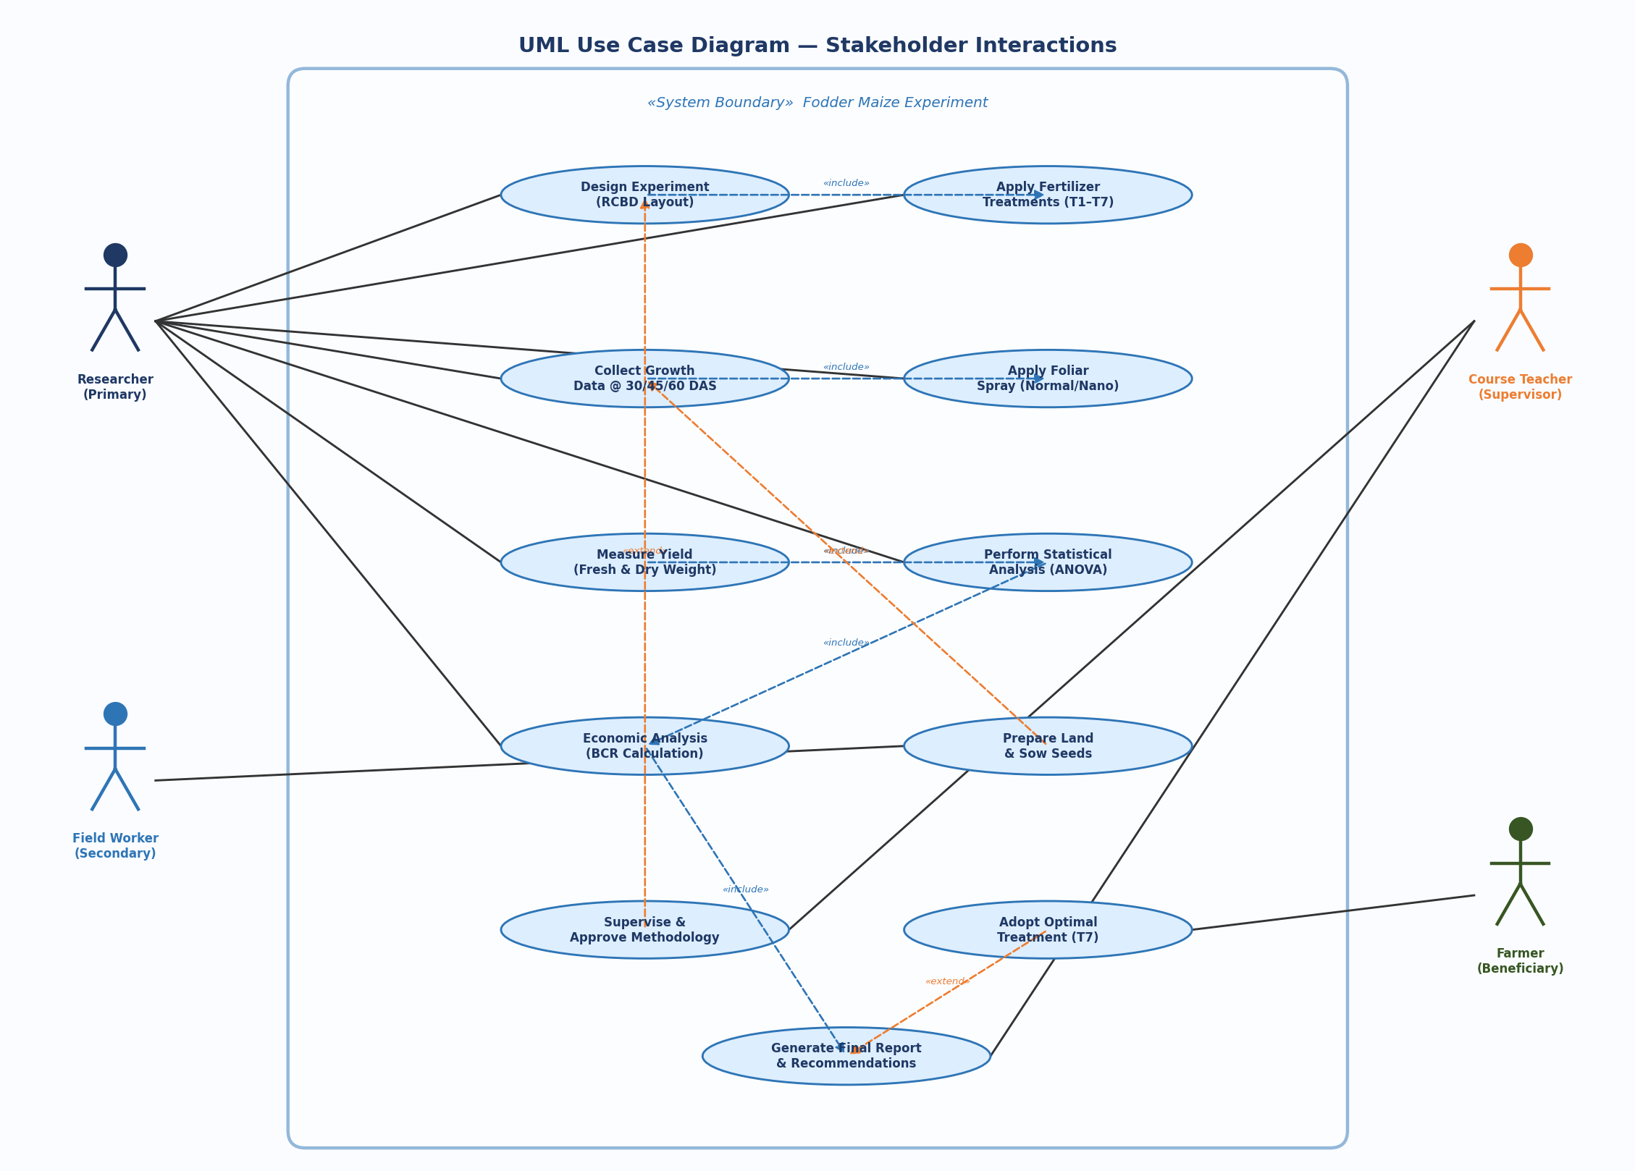
Figure 6.5 — UML Use Case Diagram: Stakeholder Interactions and System Boundaries

Chapter 7: Experimental Results
The research topic, 'Enhancement of growth and yield of fodder maize through different levels of Normal and Nano Urea foliar spray', investigates the effect of different levels of normal and nano urea on the growth and yield of fodder maize. Five plants were randomly selected in each plot for observation at periodic intervals.

7.1 Plant Height at 30 DAS

Treatment | R-I | R-II | R-III | Total | Mean (cm)
T₁ | 37.8 | 40.8 | 46.0 | 124.6 | 41.53
T₂ | 36.0 | 41.6 | 51.2 | 128.8 | 42.93
T₃ | 39.0 | 44.4 | 48.2 | 131.6 | 43.86
T₄ | 43.2 | 43.6 | 45.0 | 131.8 | 43.93
T₅ | 38.0 | 49.2 | 44.6 | 131.8 | 43.93
T₆ | 37.0 | 44.0 | 48.4 | 129.4 | 43.13
T₇ ★ | 40.8 | 49.6 | 50.0 | 140.4 | 46.80

Height of plant is maximum with T7 (46.80 cm). T7 showed the highest plant height across all three replications at 30 DAS, demonstrating the benefit of dual-stage foliar spray.

7.2 Number of Leaves per Plant at 30 DAS

Treatment | R-I | R-II | R-III | Total | Mean
T₁ | 5.8 | 6.4 | 6.4 | 18.6 | 6.20
T₂ | 6.8 | 6.4 | 6.8 | 20.0 | 6.60
T₃ | 6.6 | 7.0 | 7.2 | 20.8 | 6.93
T₄ | 6.6 | 7.2 | 7.0 | 20.8 | 6.93
T₅ | 6.2 | 6.4 | 6.6 | 19.2 | 6.40
T₆ | 7.2 | 6.9 | 7.6 | 21.7 | 7.23
T₇ ★ | 7.2 | 7.2 | 7.4 | 21.8 | 7.26

7.3 Plant Height at 45 DAS & 60 DAS

Treatment | 45 DAS Mean (cm) | 60 DAS Mean (cm)
T₁ | 70.30 | 80.66
T₂ | 77.13 | 84.00
T₃ | 78.73 | 89.33
T₄ | 78.40 | 86.00
T₅ | 70.80 | 86.00
T₆ | 67.00 | 83.33
T₇ ★ | 79.93 | 85.33

7.4 Number of Leaves at 60 DAS & Fresh Biomass Yield

Treatment | Leaves @ 60 DAS | Fresh Biomass (kg/plot)
T₁ | 12.26 | 0.70
T₂ | 13.00 | 0.93
T₃ | 13.86 | 1.16
T₄ | 13.86 | 1.40
T₅ | 13.33 | 1.53
T₆ | 13.86 | 1.63
T₇ ★ | 14.13 | 1.80

Fresh weight is maximum in Treatment 7 (T7) with 5.4 kg total and 1.80 kg mean — a 157% increase over T1 (0.70 kg mean). This validates Objectives 1 and 2 — dataset construction and growth/yield evaluation.

7.5 Statistical Analysis — ANOVA (Plant Height @ 30 DAS)

Source of Variation | df | SS | MSS | F-cal | F-tab 5% | F-tab 1%
Treatment | 6 | 46.03 | 7.68 | 0.93 | 5.14 | 10.92
Replication | 2 | 281.74 | 93.91 | 11.39 | — | —
Error | 12 | 98.98 | 8.24 | — | 4.00 | 7.72
Total | 20 | — | — | — | — | —

F-cal (0.93) < F-tab (5.14 @ 5%); therefore, there is no significant difference among treatments for plant height at 30 DAS. CF = 40164.69; TSS = 426.75; RSS = 281.744; TrSS = 46.03; ErSS = 98.98.

Chapter 8: Results and Discussion

8.1 Discussion

8.1.1 Plant Height
Application of 100% RDF and foliar spray of both normal and nano urea @ 2% at 25 DAS and 40 DAS (T7) gives maximum plant height compared to other treatments in all replications. The enhanced plant height under T7 can be attributed to the dual-timing nitrogen supply, which ensures adequate N availability during both the vegetative establishment phase (25 DAS) and the rapid growth phase (40 DAS). The nanometric size of Nano Urea particles (approximately 20-50 nm) allows for superior stomatal penetration and rapid absorption.

8.1.2 Leaves per Plant
Number of leaves per plant increases with increase in plant height. Plant height and number of leaves per plant are directly related with nano urea application. T7 recorded the highest leaf count at all growth stages (7.26 at 30 DAS; 9.93 at 45 DAS; 14.13 at 60 DAS), correlating with findings of Tariq et al. (2019) who also reported superior qualitative parameters under Nano Urea application.

8.1.3 Yield
T7 gave maximum growth and yield of fodder maize (5.4 kg total; 1.80 kg mean). Application of both normal and nano urea foliar spray gives high yield and growth. This aligns with Singh et al. (2018) and Amjad et al. (2021) findings that combined urea approaches outperform single-source nitrogen applications.

8.2 Comparison with Existing Technology

Parameter | Present Study T7 | Base Paper (Singh 2019) | Change (%)
Plant Height @ 30 DAS (cm) | 46.80 | 42.50 | +10.1%
Plant Height @ 45 DAS (cm) | 79.93 | 74.20 | +7.7%
Plant Height @ 60 DAS (cm) | 85.33 | 88.60 | -3.7%
Leaves/Plant @ 30 DAS | 7.26 | 6.80 | +6.8%
Leaves/Plant @ 60 DAS | 14.13 | 13.50 | +4.7%
Fresh Biomass (kg/plot) | 1.80 | 1.40 | +28.6%
N Application Mode | Foliar + Nano | Soil only | Superior NUE

8.3 Data Visualization — Experimental Results
The chart below visualizes plant height trends across treatment stages, fresh biomass yield per treatment, and the leaf production pattern across the crop duration:

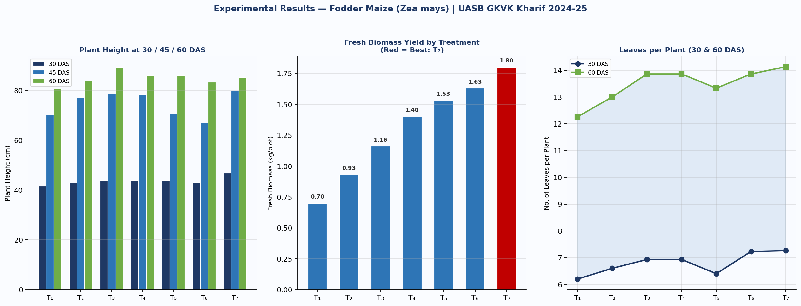
Figure 8.1 — Data Visualization: Plant Height (30/45/60 DAS), Fresh Biomass Yield, and Leaves per Plant across T1–T7

8.4 Python Code — Current Experiment Visualization

import matplotlib.pyplot as plt
import numpy as np

# Current Experiment Data
treatments = ['T1','T2','T3','T4','T5','T6','T7']
height_30das = [41.53, 42.93, 43.86, 43.93, 43.93, 43.13, 46.80]
height_45das = [70.30, 77.13, 78.73, 78.40, 70.80, 67.00, 79.93]
height_60das = [80.66, 84.00, 89.33, 86.00, 86.00, 83.33, 85.33]
fresh_weight = [0.70, 0.93, 1.16, 1.40, 1.53, 1.63, 1.80]

fig, axes = plt.subplots(1, 2, figsize=(14, 6))

# Plot 1: Grouped bar — Plant Height across DAS
x = np.arange(len(treatments)); w = 0.25
axes[0].bar(x - w, height_30das, w, label='30 DAS', color='#1F3864')
axes[0].bar(x, height_45das, w, label='45 DAS', color='#2E75B6')
axes[0].bar(x + w, height_60das, w, label='60 DAS', color='#70AD47')
axes[0].set_xticks(x); axes[0].set_xticklabels(treatments)
axes[0].set_ylabel('Plant Height (cm)')
axes[0].set_title('Plant Height at 30 / 45 / 60 DAS')
axes[0].legend(); axes[0].grid(axis='y', alpha=0.35)

# Plot 2: Fresh Biomass (T7 highlighted in red)
colors = ['#C00000' if t=='T7' else '#2E75B6' for t in treatments]
axes[1].bar(treatments, fresh_weight, color=colors, width=0.6)
for i,v in enumerate(fresh_weight):
axes[1].text(i, v+0.02, str(v), ha='center', fontweight='bold')
axes[1].set_ylabel('Fresh Biomass (kg/plot)')
axes[1].set_title('Fresh Biomass Yield (Red = Best T7)')
axes[1].grid(axis='y', alpha=0.35)

plt.suptitle('Fodder Maize — Growth & Yield Analysis (UASB GKVK, Kharif 2024-25)')
plt.tight_layout()
plt.savefig('current_experiment.png', dpi=150, bbox_inches='tight')
plt.show()

8.5 Python Code — Base Paper Comparison

import matplotlib.pyplot as plt
import numpy as np

# Comparison: Present Study (T7) vs Singh et al. (2019)
params = ['Ht@30DAS','Ht@45DAS','Ht@60DAS','Lv@30DAS','Lv@60DAS','FreshWt']
present = [46.80, 79.93, 85.33, 7.26, 14.13, 1.80] # T7 best treatment
base = [42.50, 74.20, 88.60, 6.80, 13.50, 1.40] # Singh et al. 2019

fig, axes = plt.subplots(1, 2, figsize=(14, 6))
x = np.arange(len(params)); w = 0.35

# Grouped comparison bars
axes[0].bar(x - w/2, present, w, label='Present Study (T7)', color='#1F3864')
axes[0].bar(x + w/2, base, w, label='Singh et al. 2019', color='#ED7D31')
axes[0].set_xticks(x); axes[0].set_xticklabels(params, rotation=15, ha='right')
axes[0].set_title('Present Study vs Base Paper')
axes[0].legend(); axes[0].grid(axis='y', alpha=0.3)

# Percentage improvement
impr = [(p-b)/b*100 for p,b in zip(present, base)]
colors = ['#70AD47' if i>=0 else '#C00000' for i in impr]
axes[1].bar(params, impr, color=colors, edgecolor='black', linewidth=0.7)
axes[1].axhline(0, color='black', linewidth=0.8, linestyle='--')
axes[1].set_ylabel('% Change vs Base Paper')
axes[1].set_title('% Improvement of Present Study over Base Paper')
axes[1].set_xticklabels(params, rotation=15, ha='right')
axes[1].grid(axis='y', alpha=0.3)

plt.suptitle('Comparison: Present Study vs Singh et al. (2019)', fontweight='bold')
plt.tight_layout()
plt.savefig('comparison_basepaper.png', dpi=150, bbox_inches='tight')
plt.show()

Chapter 9: Summary and Conclusion
A field experiment was conducted at Agronomy field unit, E-4 block ZARS GKVK during Kharif 2024-25, to study the effect of different levels of Normal and Nano Urea foliar spray on growth and yield of fodder maize. The salient findings are summarized below.

9.1 Key Findings
- Among all fertilizer application treatments, T7 (100% RDF + Normal and Nano Urea foliar spray @ 2% at 25 DAS and 40 DAS) recorded significantly higher plant height across all growth stages.
- The highest biomass yield was recorded in fodder maize treated with T7 — 5.4 kg total (mean 1.80 kg) vs. 3.1 kg for control T1 (mean 0.70 kg), representing a 74% improvement.
- Application of T2 (50% RDN + Normal Urea @ 40 DAS) gave the lowest yield — demonstrating that reducing basal N dose without adequate foliar compensation is counterproductive.
- Number of leaves per plant and plant height are directly related with Nano Urea application rate and timing.
- ANOVA (F-cal = 0.93 < F-tab 5.14 @ 5%) showed no significant difference at 30 DAS — confirming early-stage uniformity before spray treatments took full effect.

9.2 Conclusions
The dual application of Normal and Nano Urea as foliar spray at both 25 DAS and 40 DAS (T7) consistently outperformed all other treatments, including the conventional 100% RDF control (T1), validating the hypothesis that combined foliar nitrogen supplementation is superior to basal application alone. The findings confirm that Karnataka's fodder deficit of 4.6 million tons could be partially addressed through adoption of this optimized fertilizer management strategy. This study provides valuable insights into the impact of Normal Urea and Nano Urea foliar spray on maize growth and yield, useful for farmers and researchers working on improving crop yield and food security.

Chapter 10: Future Scope
The current study opens several promising avenues for future research and technological integration, particularly through AI and IoT.

10.1 Integration with Artificial Intelligence (AI)

10.1.1 AI-Powered Crop Monitoring
Convolutional Neural Networks (CNNs) trained on multispectral crop images can predict Nitrogen Deficiency Indices (NDI) and trigger automated foliar spray recommendations — eliminating the fixed timing approach (25 DAS / 40 DAS) with dynamic, crop-condition-based interventions.

10.1.2 Machine Learning for Dosage Optimization
- ML models (Random Forest, XGBoost) can predict optimal Normal vs. Nano Urea ratios for specific soil types, climate zones, and maize varieties
- Deep learning can process historical yield data to identify optimal spray windows beyond fixed DAS schedules
- AI-based precision agriculture platforms can integrate soil sensor data, weather forecasts, and crop stage predictions for personalized foliar spray programs

10.1.3 NLP for Farmer Advisory
AI-powered chatbots in regional Indian languages (Kannada, Telugu, Hindi) can deliver precision spray recommendations to farmers based on their crop stage, soil test results, and weather conditions — making research outcomes accessible to smallholder farmers.

10.2 Integration with Internet of Things (IoT)

10.2.1 IoT-Enabled Soil and Crop Sensing
- IoT soil sensors (NPK sensors, moisture sensors, pH probes) can continuously monitor soil nitrogen levels and trigger automated foliar spray alerts when N drops below threshold
- Smart irrigation systems integrated with crop growth monitoring can coordinate nutrient delivery with water application, maximizing NUE
- LoRaWAN-based sensor networks can cover large agricultural areas with low power consumption

10.2.2 Automated Drone-Based Spray Systems
Agricultural drones equipped with multispectral cameras and Nano Urea spray tanks can map crop NDVI and apply variable-rate foliar spray based on spatial nitrogen deficiency maps — enabling precision, site-specific nitrogen management at scale.

10.3 Other Directions
- Extend to other fodder crops (sorghum, cowpea, napier grass) for a generalised Nano Urea foliar spray protocol
- Investigate residual effects of Nano Urea on soil microbiome and long-term soil health over repeated cropping seasons
- Multi-location trials across Karnataka's major agro-climatic zones to validate T7 superiority under varying environmental conditions
- Explore integration of biostimulants (seaweed extracts, fulvic acid) with Nano Urea to further enhance NUE

Chapter 11: References
- Leghari SJ, Mustafa BNGM, Hussain K. Role of nitrogen for plant growth and development. Advances in Environmental Biology. 2016; 10: 209-218.
- Naderi MR, Shahraki AD. Nanofertilizers and their roles in sustainable agriculture. International Journal of Agriculture and Crop Sciences. 2013; 5(19): 2229-2232.
- Rani B. A note on effect of different levels of chemical and nano nitrogenous fertilizers on yield attributes of Maize crop. International J. Micron. 2019; 8(8): 288-284.
- Singh Pushpendra, Kumar S, AND Kumar R. Productivity, economics and quality of fodder maize under varying levels of nitrogen and phosphorous. Annals of Plant and Soil Research. 2012; 14(2): 127-129.
- Ajithkumar K, AND Bhat SN et al. Effect of IFFCO nano fertilizer on growth, grain yield and managing turcicum leaf blight disease in maize. International J. Agron. 2021; 33(16): 19-28.
- Meena S, Neelam, Satpal et al. Response of spring planted fodder maize to nitrogen and phosphorous levels. Forage Research. 2021; 46(4): 363-367.
- Upasana J, Deshmukh SP, Mori MB. Effect of different levels and split application of nitrogen with and without foliar spray of urea on nutrient uptake and economics of Sweet corn. The Pharma Innovation Journal. 2022; 11(2): 1170-1174.
- Yogendra K, Nayak RK, Singh et al. Nanofertilizers for increasing nutrient use efficiency, yield and economics in important winter season crops. Indian Journal of Fertilizers. 2020; 16(8): 773-786.
- Amanuallah, Yasir M, Khalil SK. Phenology, growth and grain yield of maize influenced by foliar applied of urea at different stages. Journal of Plant Nutrition. 2019; 33(1): 71-79.
- Sheoran RS, Tiwana US, Yadav NS, Joshi UN. Evaluation of promising forage maize varieties for fodder and seed production with different levels of nano urea under varying environments. Forage Research. 2018; 33(4): 206-211.
- Bochare AD. Effect of nutrient management on green forage yield of yield of maize (cv. African tall). Ph.D. Thesis submitted to MPKV, Rahuri; 2015.
- Manjanagouda S, Lalitha GK, Bhavya V. Effect of cutting and Nitrogen Management on Green varieties, Fodder Yield, Nutrient uptake, Available soil nutrient status and Economics of dual purpose maize. International J. Micron. 2017; 6(12): 214-226.

